WEDE5020
Keagile
Makhafola
ST10506576

TABLE OF CONTENTS

Page

Organisation Overview, Website Goals and Objectives, Current
Website Analysis, Proposed Website Features and Design and User Experience…………………………………………………………………………………1

Design and User Experience Wireframe…………………………………………………………………………………2

Technical Requirements,Timeline and Milestones, Budget
and References……………………………………………………………………….3

Project Proposal
Organisation Overview
Bright Spark Electrical Services
Bright Spark Electrical Services is a fictional small electrical business based in Johannesburg, South Africa. The company was established in 2021 by a qualified electrician who initially operated independently before expanding to a small team of technicians. The business provides residential and small business electrical services, including fault finding, lighting installation, DB board repairs, wiring, plug installation and electrical maintenance.
Mission:
To provide safe, reliable and affordable electrical services while delivering professional customer service.
Vision:
To become a trusted local electrical services provider known for quality workmanship and fast response times.
Target Audience:
Homeowners, landlords, small businesses, property managers and tenants requiring professional electrical assistance.
2. Website Goals and Objectives
The website will establish Bright Spark's online presence and make it easier for potential customers to request electrical services. The main objectives are to generate leads, increase customer enquiries, display available services and improve the company's credibility.
KPIs: 100 monthly website visitors within six months, at least 20 monthly enquiries, a 5% contact form conversion rate and increased phone/WhatsApp enquiries.
3. Current Website Analysis
Bright Spark currently does not have a dedicated website and relies mainly on word of mouth referrals and social media. This limits the amount of information customers can access before contacting the company.
A professional website will provide a central location for services, contact information, testimonials and operating hours.
4. Proposed Website Features
The website will contain a Home page, About Us page, Services page, Testimonials section and Contact page. A quotation request form will allow customers to describe their electrical problem and upload photographs. Click to call and WhatsApp buttons will provide quick communication.
5. Design and User Experience
Colour Scheme: Dark navy, white and electric yellow.
Typography: Poppins for headings and Open Sans for body text.
Layout: A clean, modern and mobile first design with prominent calls to action such as “Request a Quote”.
Navigation will remain simple so users can quickly find services or contact the electrician.
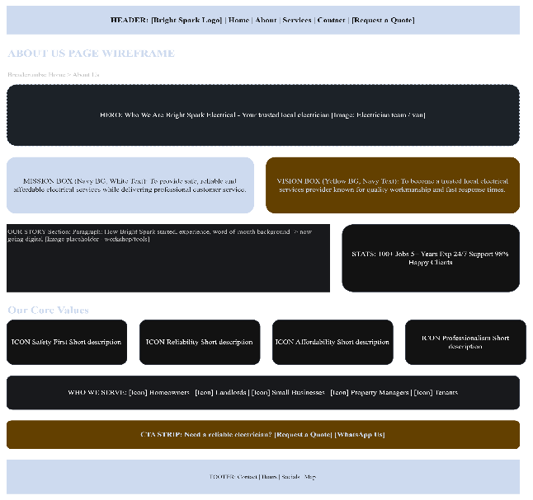
Low-Fidelity Wireframe:
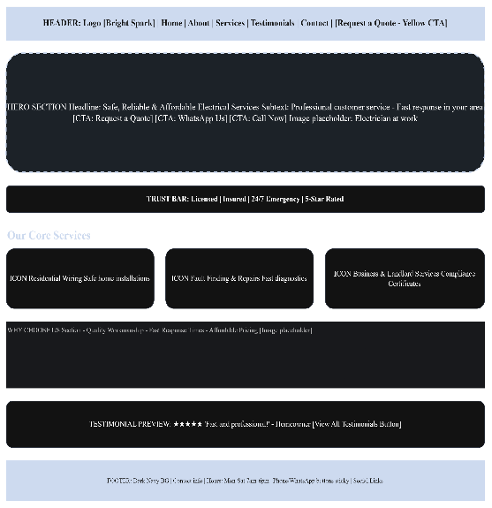
Welcome Page About US
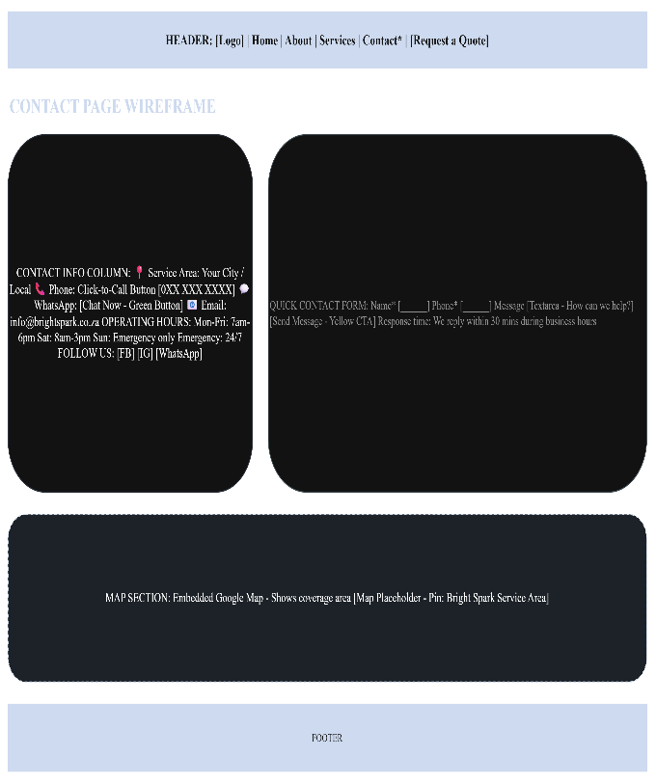
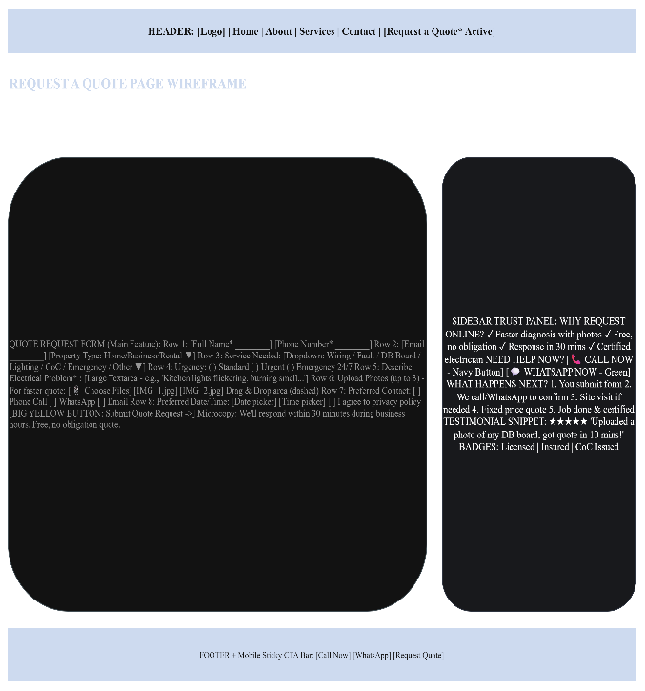
Contact page
Request a Quote page

6. Technical Requirements
The website will use HTML . It will be hosted using shared web hosting with a .co.za domain. A responsive design will ensure compatibility with smartphones, tablets and computers.
7. Timeline and Milestones
Week 1: Research and requirements
Week 2: Wireframes and design
Week 3: HTML development
Week 4: Contact form
Week 5: Testing and corrections
Week 6: Final deployment and presentation

8. Budget
Estimated development cost: R6,000
Domain and hosting: R1,200 per year
Maintenance: R500 per month
9. References
- ICASA, n.d. Electronic Communications and Telecommunications Regulations. [Online] Available at: https://www.icasa.org.za/ [Accessed 14 August 2026].
- W3C, n.d. Web Content Accessibility Guidelines (WCAG). [Online] Available at: https://www.w3.org/WAI/standards-guidelines/wcag/ [Accessed 14 August 2026].
- Google, n.d. Mobile-Friendly Websites. [Online] Available at: https://developers.google.com/search/mobile-sites [Accessed 14 August 2026].
- BrightSpark Electrical Services, 2026. Client Information and Website Requirements. [Internal project document].

Proposal 2
TABLE OF CONTENTS
Page

Organisation Overview, Website Goals and Objectives, Current
Website Analysis, Proposed Website Features and Design and User Experience…………………………………………………………………………………1
Technical Requirements,Timeline and Milestones, Budget
and References……………………………………………………………………….2

Project Proposal
1. Organisation Overview
Name: Sweet Crumbs Bakery
Sweet Crumbs Bakery is a fictional family owned bakery established in 2019 in Pretoria, South Africa. The bakery started by selling homemade cakes and pastries to customers in the local community and has since expanded to provide birthday cakes, cupcakes, biscuits, bread and customised celebration cakes.
Mission:
To create fresh, affordable and beautifully presented baked products that make customers' special occasions memorable.
Vision:
To become a recognised local bakery for quality products, creative designs and dependable customer service.
Target Audience:
Families, students, companies, event organisers and customers purchasing cakes or baked goods for celebrations.
2. Website Goals and Objectives
The website will help Sweet Crumbs attract new customers, showcase its products and simplify the ordering process. The website will also reduce repetitive enquiries by providing customers with product information, prices and ordering instructions.
KPIs: Reach 300 monthly website visitors within six months, receive at least 30 online enquiries or orders per month, achieve a 7% enquiry conversion rate and increase social-media referrals to the website.
3. Current Website Analysis
Sweet Crumbs currently operates mainly through Instagram and WhatsApp and does not have a dedicated website. Although social media provides useful photographs, customers must search through posts to find products and prices. The proposed website will organise this information into easily accessible categories.
4. Proposed Website Features
The website will include Home, About Us, Products, Gallery, Custom Cakes, Contact and Order pages. Customers will be able to browse cake categories, view photographs, select preferred flavours and submit an order enquiry. A WhatsApp button will allow customers to communicate directly with the bakery.
5. Design and User Experience
Colour Scheme: Cream, soft pink, brown and white.
Typography: Playfair Display for headings and Montserrat for body text.
Layout: The design will use large product photographs, clear pricing information and generous spacing. Navigation will be simple and mobile-friendly because many customers are expected to access the website from smartphones.
6. Technical Requirements
The website will be developed using HTML5. A .co.za domain and shared hosting package will be used. The website will be responsive and optimised for mobile devices. An image-compression strategy will be used to improve page loading speed.
7. Timeline and Milestones
Week 1: Client research and requirements
Week 2: Sitemap, wireframes and branding
Week 3: Website structure and styling
Week 4: Product gallery and order form
Week 5: Testing and optimisation
Week 6: Deployment and final evaluation

8. Budget
Estimated development cost: R7,000
Domain and hosting: R1,200 per year
Maintenance and content updates: R600 per month
9. References
- W3C, n.d. Web Content Accessibility Guidelines (WCAG). [Online] Available at: https://www.w3.org/WAI/standards-guidelines/wcag/ [Accessed 14 August 2026].
- Google, n.d. Mobile-Friendly Websites. [Online] Available at: https://developers.google.com/search/mobile-sites [Accessed 14 August 2026].
- South African Revenue Service (SARS), n.d. Tax and Small Business Information. [Online] Available at: https://www.sars.gov.za/ [Accessed 14 August 2026].
- Sweet Crumbs Bakery, 2026. Client Information and Website Requirements. [Internal project document].
- Canva, n.d. Design School. [Online] Available at: https://www.canva.com/designschool/ [Accessed 14 August 2026].

